



School: ............................................................................................................. Campus: ....................................................... Academic Year: ...................... Subject Name: ........................................................... Subject Code: ..........................

Semester: ............... Program: ........................................ Branch: ......................... Specialization: .......................... Date: .....................................

(Learning by Doing and Discovery)

**\* Coding Phase: Pseudo Code / Flow Chart / Algorithm**

ALGORITHM:

1. **Start.**
2. Open the Proof of Work Simulator in the Brave browser.
3. Initialize the blockchain layout:

* Multiple blocks (e.g., Block #1, Block #2...) will be visible.

1. For each block i from 1 to N (where N is total number of blocks):

* Click on the "Mine" button of Block i.
* Wait until the block turns green, indicating a valid hash is found (starts with leading zeroes).
* Continue to the next block.

1. Modify the data in any block (e.g., Block #1) to simulate tampering.
2. Observe the result:

* The selected block and all subsequent blocks will turn red.
* This indicates the blockchain is broken due to invalid hash chaining.

1. Click "Clear" to reset the simulation.
2. End.

# * Software used

1. Brave Web Browser - For running the Proof of Work Simulator.
2. Online Proof of Work Simulator (BCAM- Blockchain Academy Mittweida) – A web-based tool to visualize the mining process and hash linking between blocks.

Open the Proof of Work Simulator on our brave browser.

The page will load a visual simulator with multiple blocks.

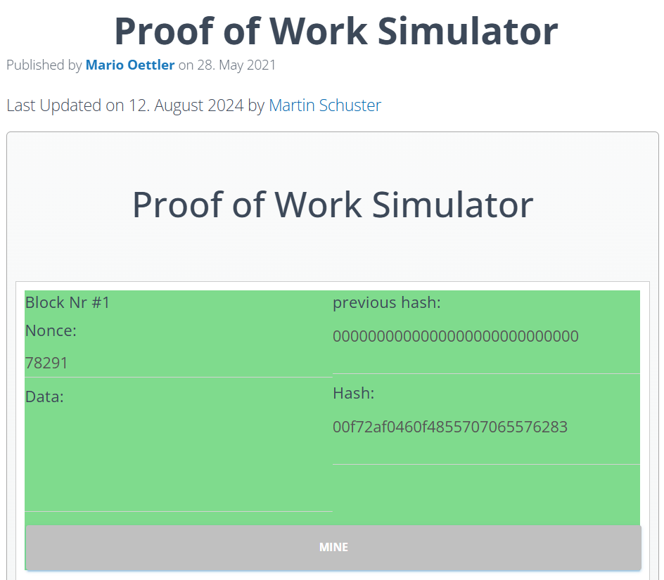

Explore the Interface:

We’ll find a series of blocks labeled Block #1, Block #2, and so on.

Each block contains:

* A Data input field.
* A Nonce value.
* A Previous Hash referencing the hash of the prior block.
* A Hash representing the current block’s cryptographic fingerprint.
* A Mine button to initiate the mining process

**Mining the First Block:**  
 Click on the “Mine” button for Block #1. The simulator will begin searching for a valid nonce that results in a hash starting with a required number of leading zeroes (e.g., 00...). Once found, the block will turn green, indicating it has been successfully mined.

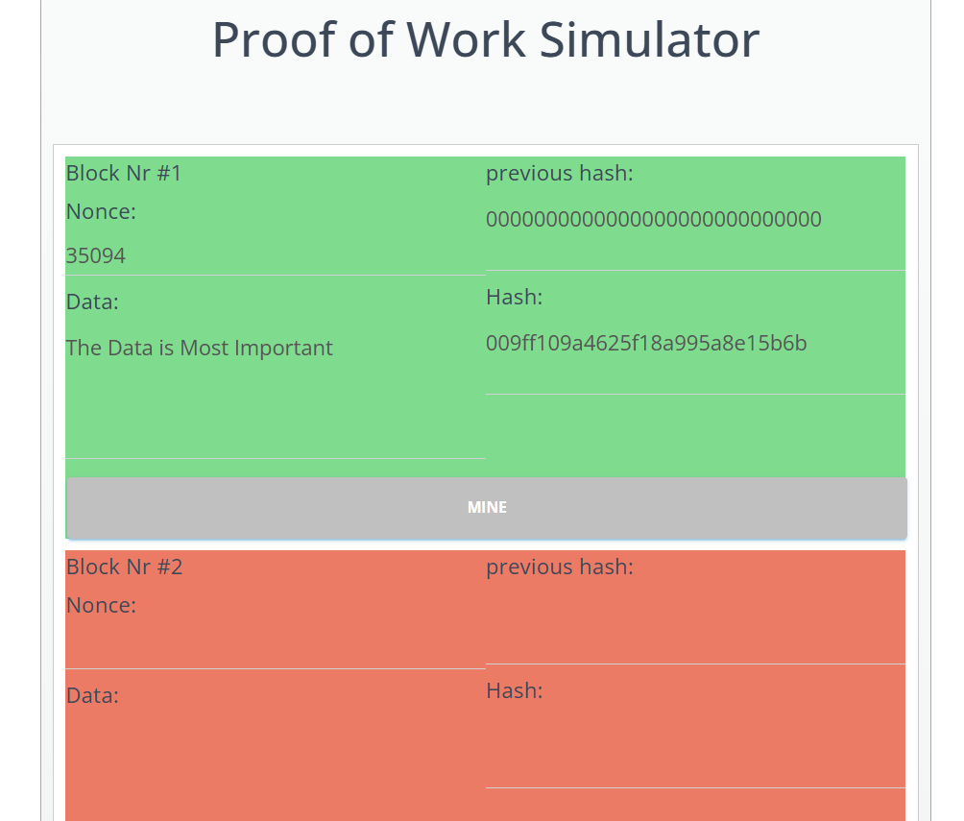

**Proceed to the Next Block (Block #2):**  
 Block #2 automatically uses the hash value of Block #1 as its Previous Hash reference.  
Click on the “Mine” button for Block #2.

The simulator will once again calculate a valid nonce, and upon success, the block will turn green—signifying that it has been correctly mined and validated.

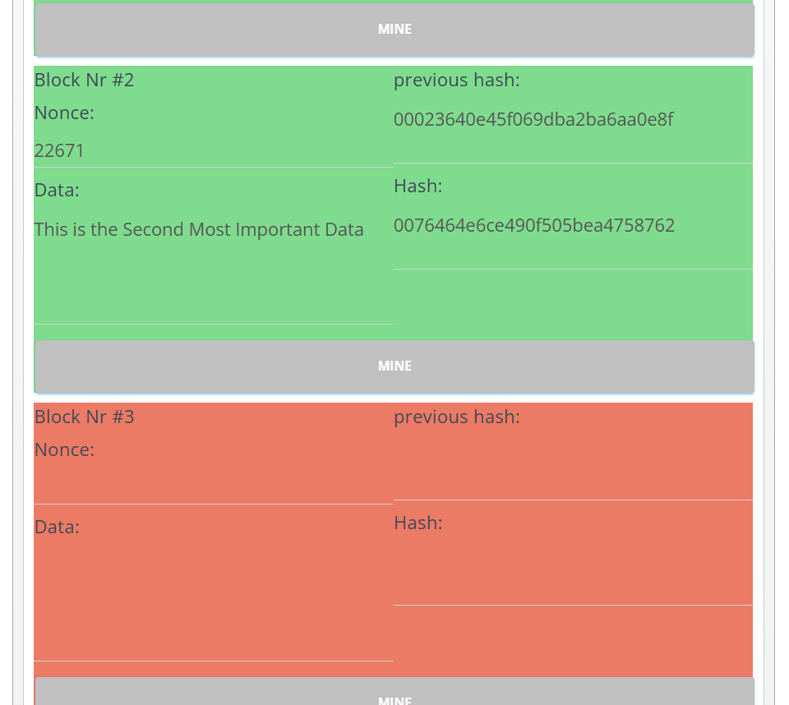

**Continue Mining Subsequent Blocks:**  
Repeat the mining steps for Block #3, Block #4, and any remaining blocks. Remember, each block relies on the hash of its preceding block, maintaining a sequential dependency.

Now, alter the **Data** field in Block #1. You will notice that the hash of Block #1 changes, and all following blocks turn red. This indicates that the chain has been disrupted due to data alteration—demonstrating how blockchain technology preserves data integrity and immutability through cryptographic linking.

## * Implementation Phase: Final Output (no error)

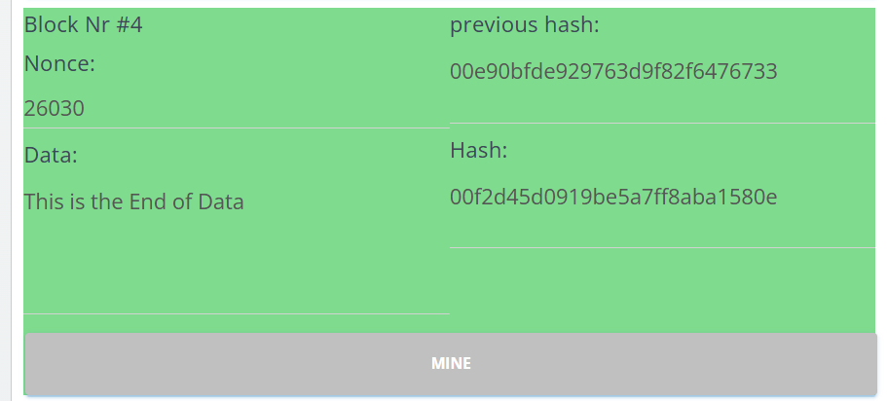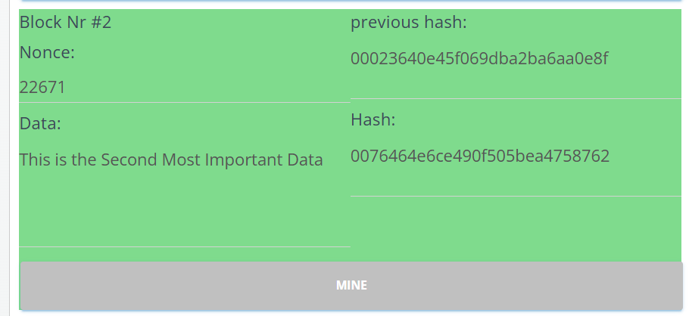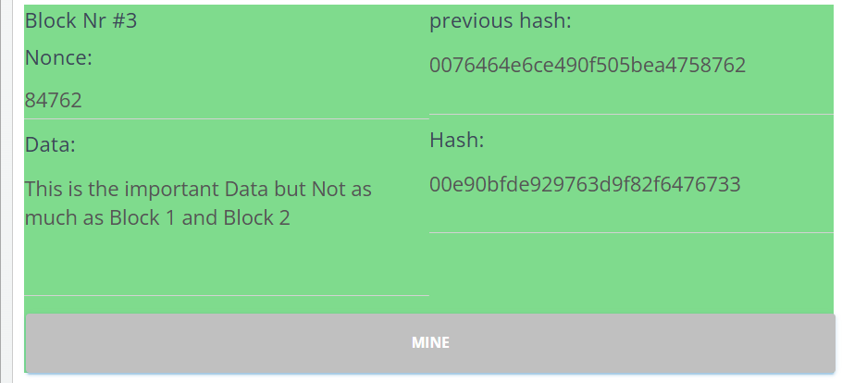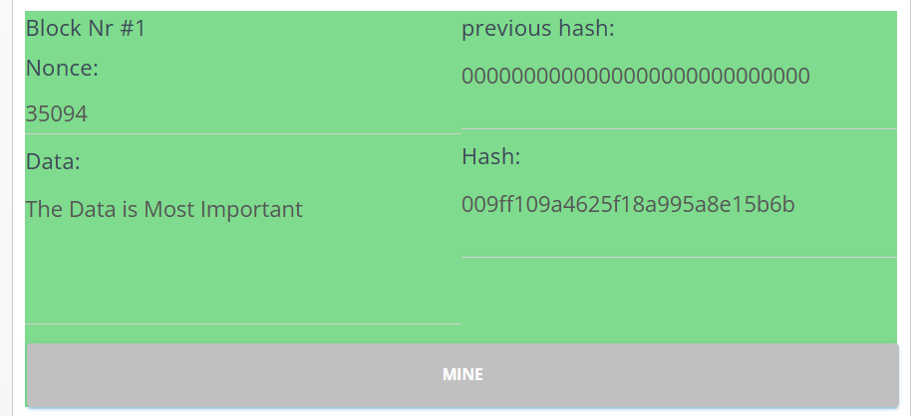Applied and Action Learning

Now we see successfully completed the mining of all the blocks.

# * Observations

# I observed that each block required mining to generate a valid hash with leading zeroes.

# Once mined, the block turned green, indicating successful validation.

# When I changed the data in Block #1, it caused all the following blocks to turn red.

# This showed how any change breaks the chain, proving the importance of linking through secure hashes.

# The simulator clearly demonstrated how Proof of Work maintains the integrity of the blockchain.



|  |  |  |  |
| --- | --- | --- | --- |
| **Rubrics** |  |  |  |
| Concept | 10 |  |  |
| Planning and Execution/  Practical Simulation/ Programming | 10 |  |  |
| Result and Interpretation | 10 |  |  |
| Record of Applied and Action Learning | 10 |  |  |
| Viva | 10 |  |  |
| **Total** | **50** |  |  |

***Signature of the Student:***

***Signature of the Faculty:***

